FCNI Annual Conference – 2023
September 23, 2023
10:00 am – 2:30 pm Central Time (CT)

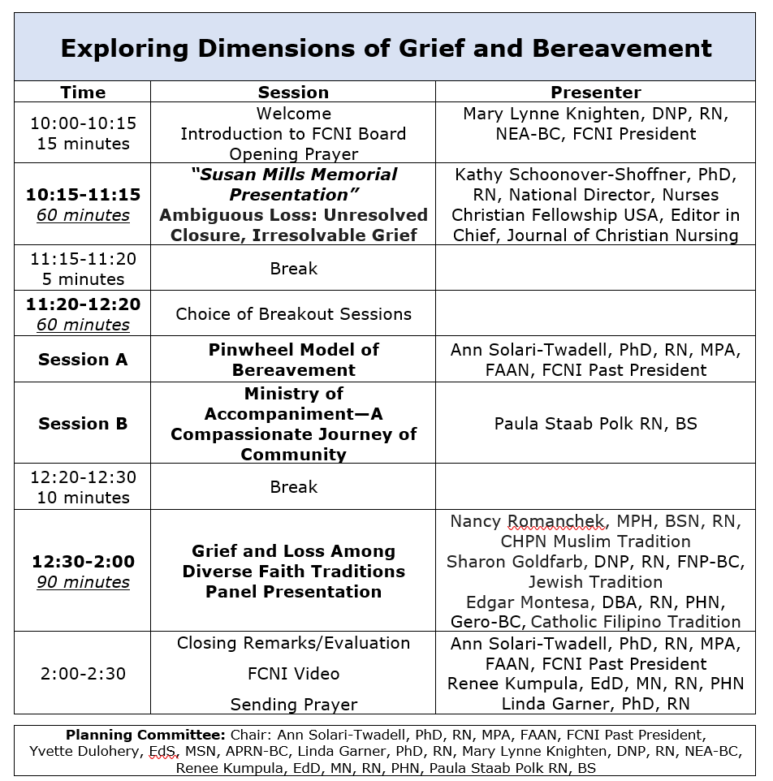

When: Saturday, September 23, 2023
Time: 10:00 am to 2:30 pm Central Time (CT)
Registration:
Early Bird Registration through 8/31/2023
Members: $90.00
Nonmembers: $140.00
Registration 9/1/23 to 9/23/2023Members $100.00 Nonmembers $150.00
To Register: https://www.fcninternational.org/event-5374669

